Task# 1
STAKEHOLDER ANALYSIS MAP USING LUCID CHART

Problem statement:
Marathi subject teachers face significant challenges in maintaining student engagement during classroom teaching due to low student interest, limited participation, and ineffective interaction, which negatively impacts language learning outcomes.

Stakeholder identification:
Subject Teacher
Students
Parents

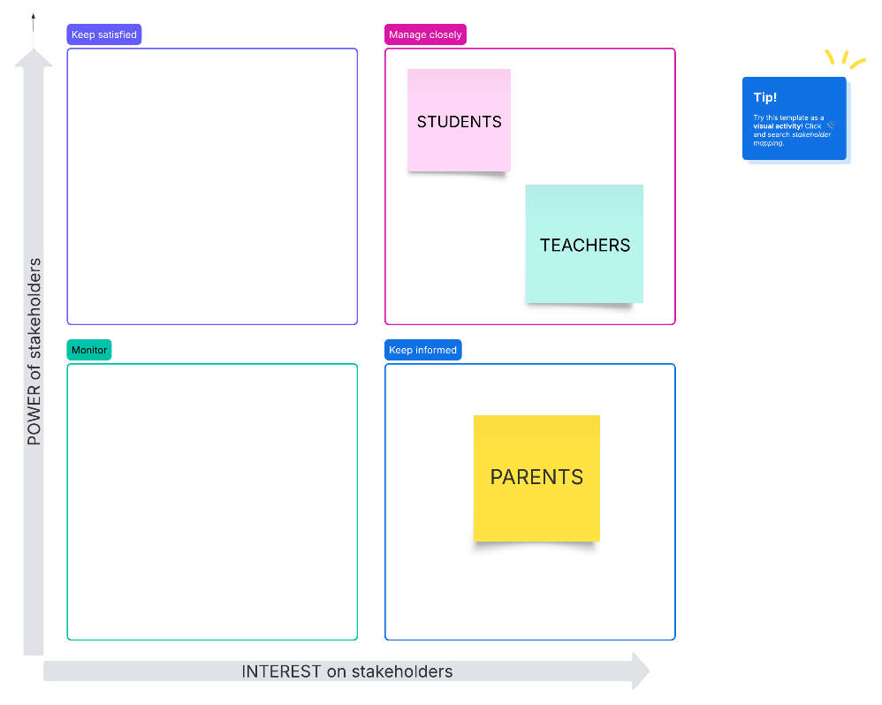
MAP:

